| NSW Department of Education

North Nowra Public School Behaviour Support and Management Plan
Overview
North Nowra Public School is committed to explicitly teaching and modelling positive behaviour and to supporting all students to be engaged with their learning. Key programs prioritised and valued by the school community are The North Nowra Way, How 2 Learn, and The Zones of Regulation in conjunction with explicit teaching from the Bounce Back teacher resource.

Promoting and reinforcing positive student behaviour and school-wide expectations
North Nowra Public School has the following school-wide rules and expectations known as The North Nowra Way:
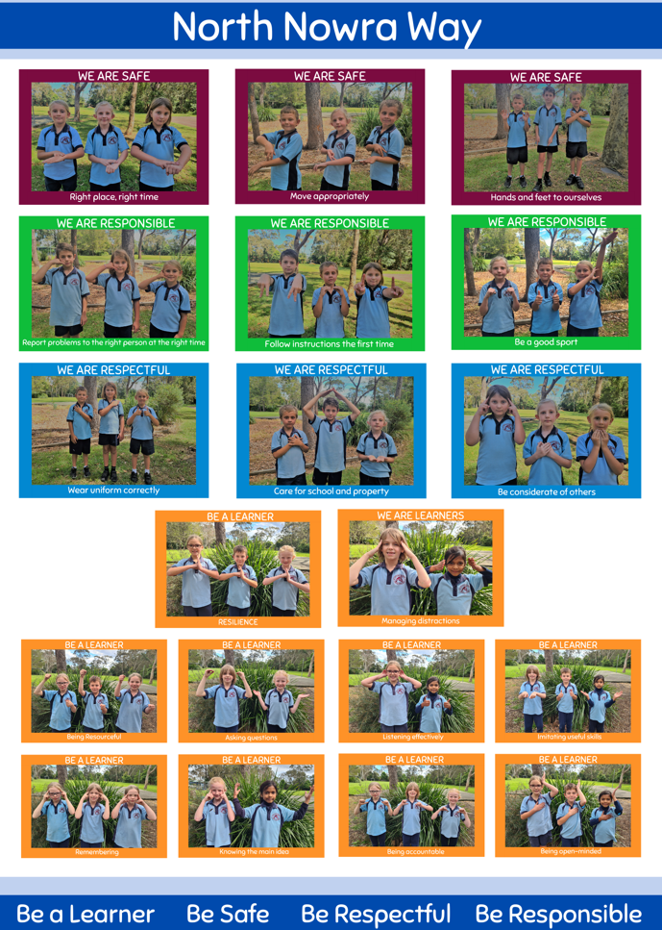

North Nowra Public School uses the following strategies and systems to explicitly teach, recognise and reinforce positive student behaviour and behavioural expectations:
- A whole school curriculum to explicitly teach the expected behaviour behaviours.
- Student academic reports include behavioural expectations.
- Whole School weekly assembly recognising and reinforcing behaviours.
- A whole School rewards system based on The North Nowra Way, be a learner expectations
  - Classroom rewards systems
  - Fortnightly class assembly learning awards.
  - “The North Nowra Way Principal Medal” A prestigious award based following the North Nowra Way through out a students time at North Nowra Public School.
- Each Term the North Nowra Way explicit teaching is delivered K to 6 – Student are explicitly taught expected behaviours behaviours of the North Nowra Way.

Behaviour code for students
The NSW Department of Education behaviour code for students can be found at https://education.nsw.gov.au/public-schools/going-to-a-public-school/translated-documents/behaviour-code-for-students
High expectations for student behaviour are established and maintained through effective role modelling, explicit teaching and planned responses.

Whole School Approach

Care Continuum | Strategy or Program | Details | Audience
Prevention | The North Nowra Way | Core values and behaviours which underpin our positive school culture. | Students  Parents  Staff
Prevention | Bounce Back | Evidence based Anti-Bullying and resilience program to support explicit teaching | TEacher
Prevention | Zones of Regulation | Evidence based Regulation program to establish common language across the school community to support emotional regulation and develop tools to return to the “Green Zone’ where learning happens | Students  Teacher  School Community
Prevention | Professional Learning | Classroom management and playground management practices | Staff
Prevention | Parent forums | Parent forums with keynote speakers on student behaviour and wellbeing. | Parents
Early Intervention | Classroom management | Communication with parents, and where relevant, the use of communication books.  Explicit teaching and modelling of specific skills including behaviour expectations and social/emotional regulation skills and tools. | Students  Parents  Staff
Early Intervention | Learning Support  Team & Teacher | Referral to learning support team for academic, social, emotional support.
Early Intervention | Social Stories, visual cues and strategies, and routines. | Curriculum links, particularly in PDHPE, History and English (literature)  Restorative practices and circle time  Drama and role play  Self-regulation training – brain breaks, yoga, heavy work, weighted blankets | Students
Early Intervention | Buddy programs and mentoring. | Formal “Buddy Program” for Kindergarten students initiated as part of orientation/transition program. | Students
Early Intervention | Anti-bullying strategies including cyber-bullying and internet safety. | Incursions and Support programs including Brave Hearts  Annual Police Liaison Officer Cyber safety program. | Students  Parents
Early Intervention | School Counselling Service | School counselling staff support students by providing a psychological counselling, assessment and intervention service. | Students  Parents  Staff
Early Intervention | Aboriginal Education | Support programs aimed at connection to Country and community for Aboriginal and Torres Strait Islander young people. | Students  Staff
Targeted Intervention | Individual behaviour plans | Modified individual expectations and goals.  School developed programs to support behaviour and wellbeing | Students  Parents  Staff
Targeted Intervention | Dojo Messaging system and communication books | Communication with parent/carer for positive and negative monitoring of behaviour and, where relevant, communication books | Students  Parents  Staff
Targeted Intervention | Transition strategies | Class to playground, lesson to lesson, grade to grade, school to school. | Students  Parents  Staff
Individual Intervention for students | School Learning Support  Officers | SLSO support for implementation of modified individual expectations and goals.  School developed programs to support behaviour and wellbeing | Students  Parents  Staff
Individual Intervention for students | Sensory assessment and supports. | Implemented as required in consultation with specialists and parents. | Students  Parents  Staff
Individual Intervention for students | Negotiated playground programs. | Implemented as required in consultation with specialists and parents. | Students  Parents  Staff
Individual Intervention for students | Phone Intervention Program | Dedicated School Administration Officer to monitor, follow up and record attendance issues. | Students  Parents  Staff
Individual Intervention for students | Delivery Support Team | Develop appropriate behaviour expectations and strategies with other staff members.  Monitor the impact of support for individual students through continuous data collection.  Provide consistent strategies and adjustments outlined within an individual student support plan. | Students  Parents  Staff
Individual Intervention for students | Specialist allied health services | Allied health services to ensure learning adjustments are appropriate and effective for students. | Students  Parents  Staff
Individual Intervention for students | Itinerant Support Teachers | Students with disabilities or significant support needs may access help from itinerant support teachers (hearing and vision, conductive hearing loss, early intervention and support teacher transition) who visit schools and work directly with the student to plan and develop personalised learning and support. | Students  Parents  Staff
Individual Intervention for students | Professional Learning | Whole school professional learning relating to the specific needs of students.  Targeted professional learning for staff. | Staff

Detention, reflection and restorative practices

Action | When and how long? | Who coordinates? | How are these recorded?
Classroom detention, reflection and restorative practices | As required | Classroom Teacher | Teacher Diary
Playground detention, reflection and restorative practices | As required | Stage Assistant Principal | Sentral

Partnership with parents/carers
North Nowra Public School partners with parents/carers in establishing expectations for parent engagement in developing and implementing student behaviour management strategies through consultation with the North Nowra P&C.
North Nowra Public School will communicate these expectations to parents/carers by our communications strategy including our website, app and social media. As well as parent information sessions throughout the year, and individual student case conferences as required.

School Anti-bullying Plan
Insert a link to the school’s existing anti-bullying plan here. Refer to the

Reviewing dates
Last review date: February 2023
Next review date: Day 1, Term 1, 2024

education.nsw.gov.au

